About Us:-

**1**: Introduction: MTTP

**2: Our Mission**To create an enabling environment for Pakistan’s tourism industry by providing world-class facilities that commensurate with our rich cultural heritage, rare archaeological treasures and exquisite environmental beauty in close partnership and coordination between the public and the private sector while preserving and protecting our cultural and moral values and projecting tourist friendly image of the country.

**3: Our Vision**

The Vision is to develop the tourism sector as a national priority in a sustainable and acceptable manner, taking full advantage of regional and international trends and developments so that it can significantly contribute to the improvement of quality of life in Pakistan whilst promoting the country’s cultural and natural heritage.

**4: Our Team**

1. **Shamshair Ali  
   Founder/General Manager**

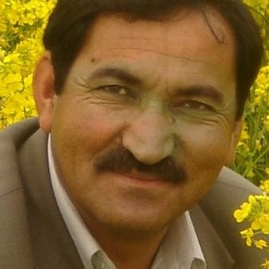

1. **Akhon Ibrahim   
    Co-Founder/Tour Guide**  
   
2. **Kaleem Ali**

**Managing Director/Graphic Designer**



1. **Xayyal Amin**

**Tour Manager/Tour Guide** 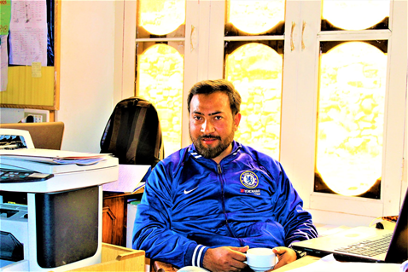

1. **Muhammad Saleem**

**Tour Guide (Baltoro trek)**

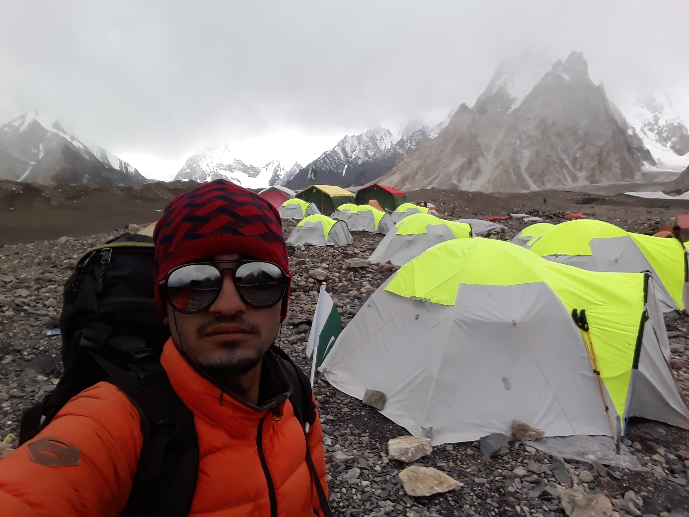

1. **Muhammad Aqeel   
    Media In-charge/Tour Guide**

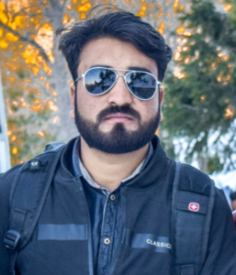

**Cook for Baltoro Trek**

1. **Ali Malikpa (Head Cook)**

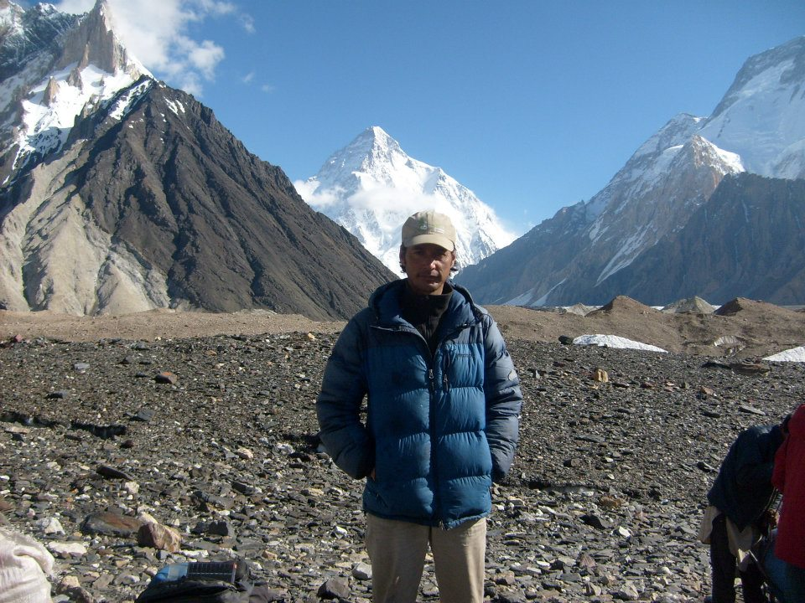

1. **Muhammad Ilyas (Assistant Cook)**

